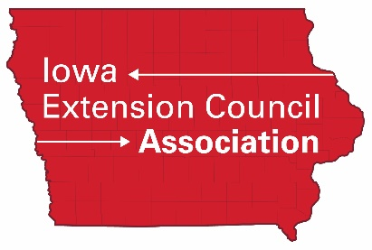

Candidate Profile

IECA Board of Directors Nomination Application

General Candidate Information
Please type your responses into the gray boxes.

Name: Region: County:

Address: City: Zip:

Phone: Home Cell Number of Years on Extension Council (including 2022)

E-mail Address:

Profession/Career information:

Please check the topics below that you are interested in. These will be used to help identify potential board members to serve on various committees, if elected.

politics/legislation
presenting/teaching
human resources
communications/marketing
finance/accounting
youth/4-H
human sciences
agriculture
community and economic development

Please answer the following questions (please limit your responses to no more than 2 pages):

- Why are you interested in serving on the Iowa Extension Council Association’s Board of Directors?

- What contributions do you feel you could make to this association?

- What types of experiences you have you had on your extension council? You may wish to include offices held, committees served on, or projects you assisted with.

- Please tell us briefly about yourself.

Please return this profile postmarked by April 15 to:
IECA
611 Roosevelt St.
Lisbon, IA 52253
E-mail: ieca@iaextensioncouncils.org

